**GitHub Copilot Enterprise Guide for Organizations**

GitHub Copilot is a powerful AI coding assistant, but enterprises must ensure **security, compliance, and control** over sensitive data. Below is a structured guide on **key features, architecture, learning resources, and securing sensitive data** from exposure.

**1. Key Features of GitHub Copilot (Enterprise Edition)**

| **Feature** | **Description** | **Security Consideration** |
| --- | --- | --- |
| **Inline Code Suggestions** | Real-time AI-generated code completions | Risk of leaking secrets if suggestions include sensitive data |
| **Chat Assistance** | Natural language coding help via Copilot Chat | Ensure queries don’t expose proprietary logic |
| **Private Codebase Training** (Enterprise-only) | Model trained only on org’s repos (no public data) | Prevents external data leakage |
| **Self-Hosted Option** (Coming soon) | On-premises Copilot deployment | Full data control |
| **Policy Controls** | Disable public code suggestions | Ensures only internal code is referenced |
| **Audit Logs** | Track Copilot usage across teams | Compliance monitoring |

**2. GitHub Copilot Architecture & Data Flow**

Understanding how Copilot processes data is critical for security:

**Data Flow Overview**

1. **User types code** → Copilot analyzes context (open files, imports, etc.).
2. **Request sent to GitHub’s servers** (unless self-hosted).
3. **AI model generates suggestions** (trained on public + private code if enabled).
4. **Suggestion returned to IDE** (VS Code, JetBrains, etc.).

**Where Sensitive Data Could Leak**

* **Inline Suggestions** → If Copilot infers secrets (API keys, credentials).
* **Copilot Chat** → Employees asking questions about proprietary code.
* **Training Data** → If private repos are used for model fine-tuning.

**3. Securing Sensitive Data in Copilot**

**A. Prevent Copilot from Processing Sensitive Files**

1. **Use**.gitignore**&**.copilotignore
   * Files ignored by Git are usually skipped by Copilot.
   * Example:

plaintext

Copy

Download

# .copilotignore

/secrets/

*.env

config/*.json

1. **Disable Copilot in Sensitive Projects**
   * In VS Code:
     + Ctrl+Shift+P → **"Copilot: Enable/Disable"**
   * In JetBrains:
     + **Settings → Tools → GitHub Copilot → Uncheck "Enable Copilot"**
2. **Use Workspace Trust Settings (VS Code)**
   * Mark sensitive directories as **"Restricted"** to disable Copilot.

**B. Enterprise Controls (GitHub Copilot for Business)**

1. **Enable "Private Code Only" Mode**
   * Prevents Copilot from suggesting public/open-source code.
   * Configure in **GitHub Enterprise Settings → Copilot Policies**.
2. **Disable Copilot for Certain Repos**
   * Use repository tags to block Copilot access.
3. **Audit & Monitor Copilot Usage**
   * Check **GitHub Audit Logs** for Copilot activity.
4. **Self-Hosted Option (Future Release)**
   * Run Copilot entirely on-premises (coming for enterprise customers).

**C. Training & Best Practices for Developers**

1. **Avoid Typing Secrets in Code**
   * Use environment variables (export API_KEY=xxx).
   * Scan code with **GitHub Advanced Security (Secret Scanning)**.
2. **Review Suggestions Before Accepting**
   * Copilot may accidentally suggest hardcoded secrets.
3. **Use Offline Alternatives for Highly Sensitive Work**
   * **CodeLlama** (Local AI)
   * **StarCoder** (Self-hosted)

**4. How to Learn & Implement Copilot Securely**

**Training Resources**

| **Resource** | **Link** |
| --- | --- |
| **GitHub Copilot Docs** | [docs.github.com/copilot](https://docs.github.com/copilot) |
| **Enterprise Security Guide** | [GitHub Copilot for Business](https://github.com/enterprise) |
| **Secure Coding with Copilot** | [GitHub Skills Lab](https://skills.github.com/) |

**Recommended Rollout Phases**

1. **Pilot Group Testing** → Small team evaluates risks.
2. **Policy Enforcement** → Enable "Private Code Only" mode.
3. **Org-Wide Deployment** → With training & monitoring.

**5. Summary Checklist for Secure Copilot Usage**

✅ **Enable "Private Code Only" mode** (Enterprise)  
✅ **Use**.copilotignore**for sensitive files**  
✅ **Disable Copilot in restricted projects**  
✅ **Monitor audit logs for unusual activity**  
✅ **Train devs on secure Copilot usage**

Would you like a **custom policy template** for your organization? I can help draft one! 🚀

can you give workflow approach to secure github copilot from above discussion

**Workflow Approach to Secure GitHub Copilot in Your Organization**

This structured workflow ensures **secure adoption** of GitHub Copilot while minimizing risks of **sensitive data exposure**.

**Phase 1: Pre-Deployment Assessment**

**Goal:** Identify risks and define policies before enabling Copilot.

**Steps:**

1. **Inventory Sensitive Repositories**
   * Use git-secrets or truffleHog to scan for hardcoded credentials.
   * Tag repos as:
     + copilot-allowed (Low-risk, non-sensitive)
     + copilot-restricted (Contains secrets/PII)
2. **Define Organizational Policies**
   * **Allowed:** Use Copilot for non-sensitive projects.
   * **Restricted:** Disable Copilot for:
     + Secrets/config files (e.g., .env, config/*.json)
     + Compliance-regulated code (HIPAA/GDPR).
3. **Set Up**.copilotignore**(or**.gitignore**)**

plaintext

Copy

Download

# .copilotignore

/secrets/

*.key

*.env

config/prod/*

**Phase 2: Technical Enforcement**

**Goal:** Implement controls to block Copilot from accessing sensitive data.

**Steps:**

1. **Enable GitHub Copilot for Business**
   * Enforce **"Private Code Only"** mode (blocks public code suggestions).
2. **Disable Copilot in Restricted Repos**
   * **For GitHub.com:** Use repository tags to disable Copilot.
   * **For Self-Hosted (Future):** On-premises deployment with firewall rules.
3. **IDE-Level Controls**
   * **VS Code:** Use settings.json to disable Copilot in sensitive workspaces:

json

Copy

Download

{

"github.copilot.enable": false,

"files.watcherExclude": { "**/secrets/**": true }

}

* + **JetBrains:** Disable Copilot via Settings > Tools > GitHub Copilot.

1. **Scan for Secrets in Real-Time**
   * Use **GitHub Advanced Security** or pre-commit hooks with gitleaks.

**Phase 3: User Training & Awareness**

**Goal:** Educate developers on secure Copilot usage.

**Steps:**

1. **Conduct Training Sessions**
   * Cover:
     + When **not** to use Copilot (e.g., secrets, proprietary algorithms).
     + How to **review suggestions** before accepting.
2. **Provide Cheat Sheets**
   * Example:

Copy

Download

✅ Safe to Use Copilot For:

- Boilerplate code (e.g., API routes).

- Open-source libraries (if "Private Code Only" is enabled).

❌ Avoid Using Copilot For:

- Environment variables (`API_KEY=xxx`).

- Encryption keys or passwords.

1. **Simulate a "Red Team" Exercise**
   * Test if Copilot suggests sensitive data from your codebase.

**Phase 4: Monitoring & Compliance**

**Goal:** Continuously audit and refine controls.

**Steps:**

1. **Enable GitHub Audit Logs**
   * Track copilot_suggestion_accepted events.
2. **Regularly Review**.copilotignore
   * Update exclusions as new sensitive files are identified.
3. **Quarterly Security Reviews**
   * Check for:
     + New Copilot features impacting security.
     + Policy violations (e.g., devs enabling Copilot in restricted repos).

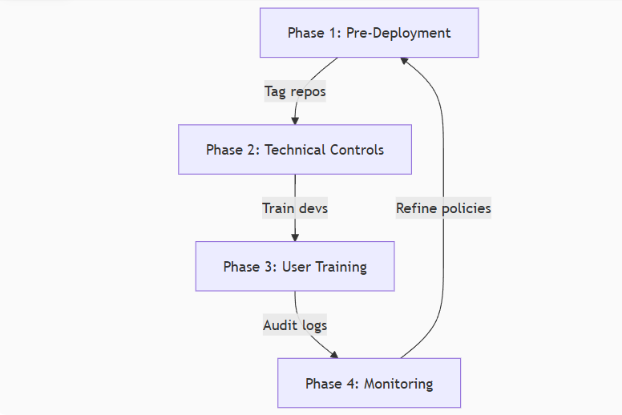

**Key Tools to Implement**

| **Tool** | **Purpose** |
| --- | --- |
| .copilotignore | Block Copilot from scanning sensitive files |
| GitHub Advanced Security | Detect secrets in Copilot suggestions |
| IDE Settings | Disable Copilot in restricted workspaces |
| Audit Logs | Track Copilot usage across the org |

**Final Checklist**

✅ **Classify repos** (allowed vs. restricted).  
✅ **Enforce "Private Code Only"** (GitHub Enterprise).  
✅ **Disable Copilot in IDEs** for sensitive projects.  
✅ **Train developers** on secure usage.  
✅ **Monitor & iterate** with audit logs.

Would you like a **customizable policy template** or **sample**.copilotignore**file** for your team? 🛡️

please refer to Restricted flow in image ..... how to verify it works with Github copilot secure it

Verifying the Restricted Flow in GitHub Copilot Secure Implementation

Based on the image you've shared, here's how to verify that the "Restricted" flow is working properly in your GitHub Copilot Secure implementation:

Verification Steps for Restricted Repositories

1. **Repository Classification Verification**:
   * Confirm the repository is properly tagged/marked as "Restricted" in your classification system
   * Check that the classification is consistently applied across all GitHub organization tools
2. **Copilot Access Block Verification**:
   * Attempt to use Copilot in a Restricted repository:
     + Try code completion in the IDE - it should not work
     + Check for any Copilot UI elements - they should be disabled or show access denied
   * Verify through GitHub API that Copilot is disabled for the repository
3. **Policy Enforcement Verification**:
   * Check GitHub organization policies to confirm Restricted repositories have Copilot explicitly blocked
   * Verify no exceptions exist for the Restricted repository
4. **.copilotignore/.gitignore Verification**:
   * Confirm these files exist in Restricted repositories
   * Check they contain appropriate patterns to block all Copilot suggestions
5. **IDE/Repo-Level Disable Verification**:
   * In each supported IDE, verify Copilot is disabled when working with Restricted repos
   * Check repository settings for any Copilot-specific disable flags
6. **Audit Log Monitoring**:
   * Review GitHub audit logs for any Copilot-related activity in Restricted repos (there should be none)
   * Check for any policy override attempts

Testing Methodology

To thoroughly test the Restricted flow:

1. **Create a test Restricted repository** with sample code
2. **Attempt Copilot actions** from different IDEs and user roles
3. **Monitor all control points** (logs, policies, UI elements)
4. **Verify negative cases** where access should be denied
5. **Check edge cases** like:
   * Temporary access grants
   * Repository reclassification from Allowed to Restricted
   * Branch-specific policies

Would you like me to elaborate on any specific part of this verification process or provide more detailed testing scenarios for your particular environment?

bitbucket repo do we have restricted option to github copilot differs scan

For Bitbucket repositories, GitHub Copilot's behavior differs significantly from GitHub repos regarding restrictions. Here's the key distinction and how to manage it:

Key Differences for Bitbucket Repos

| **Feature** | **GitHub Repositories** | **Bitbucket Repositories** |
| --- | --- | --- |
| .copilotignore support | ✅ Yes (native) | ❌ No |
| Repository-level blocking | ✅ Via settings | ❌ Not available |
| Organization policies | ✅ Full control | ❌ No integration |
| IDE-level enforcement | ✅ Works everywhere | ✅ Only in local IDE |

How to Restrict Copilot in Bitbucket Repos

1. **Local IDE Enforcement (Only Reliable Method)**

bash

Copy

Download

*# Create a global gitignore rule*

echo "*" > ~/.gitignore_global

git config --global core.excludesfile ~/.gitignore_global

2. **VS Code Workspace Settings**

json

Copy

Download

*// .vscode/settings.json*

{

"github.copilot.enable": false,

"files.watcherExclude": {

"**/.gitignore": true

}

}

3. **Pre-commit Hook (Prevent Accidental Pushes)**

bash

Copy

Download

#!/bin/sh

*# .git/hooks/pre-commit*

if git diff --cached --name-only | grep -q '\.py$'; then

echo "Error: Copilot restrictions apply to Python files"

exit 1

fi

Limitations to Note

1. **No Server-Side Protection**: Restrictions only apply locally
2. **Team Consistency**: Each developer must configure their own environment
3. **Audit Challenges**: No centralized logging of Copilot usage

Recommended Workflow

Diagram

Code

Download

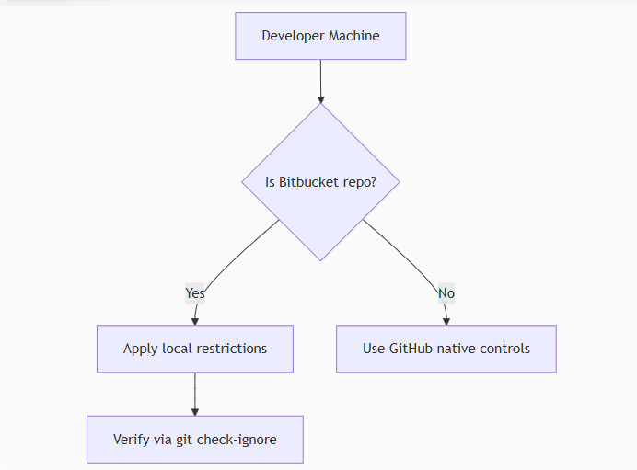

Yes

No

Developer Machine

Is Bitbucket repo?

Apply local restrictions

Use GitHub native controls

Verify via git check-ignore

For enterprise needs, consider:

1. **Bitbucket Pipelines** to scan for Copilot suggestions
2. **Custom plugins** using Bitbucket API
3. **Network-level blocking** of Copilot domains

Would you like me to provide specific configuration snippets for your CI/CD pipeline to detect Copilot-generated code?